Bill & Dave’s
Strange Brew Edge Tour
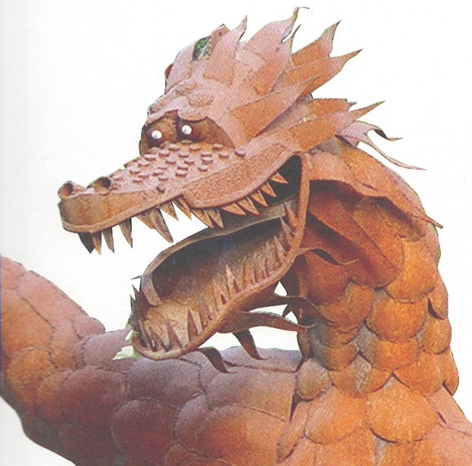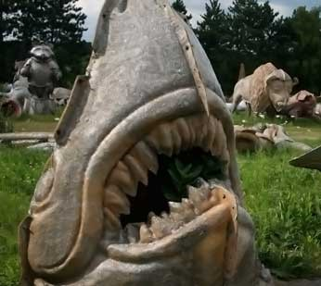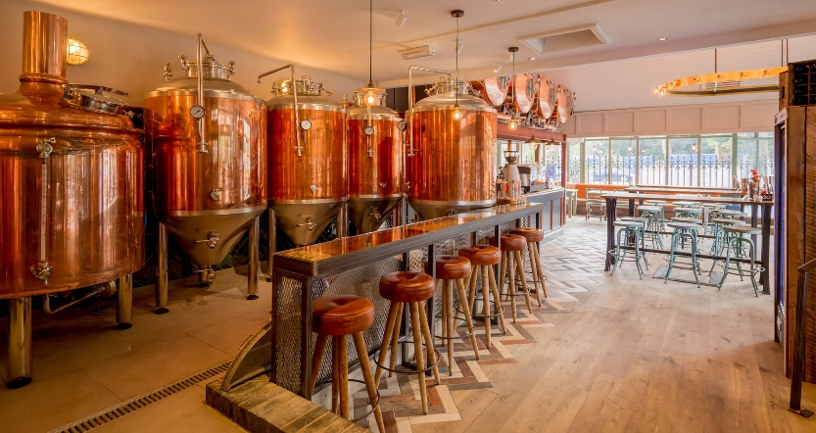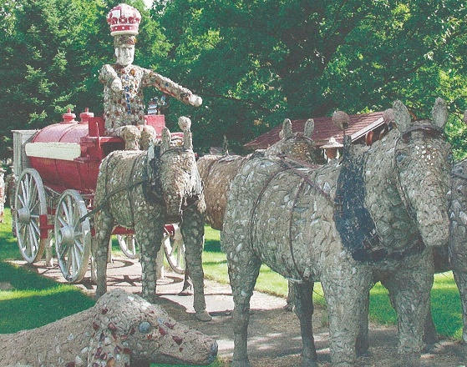
Join us on a scenic, casual ride around Wisconsin’s highways and byways visiting some of our most eclectic roadside attractions and breweries.
We are planning on staying at hotels and eating at taprooms when available. If you don’t want to stay at hotels it would be on you to plan your alternate stay. If you want to join us for the whole tour or just a day, we’ll start on Monday June 19 and return on Saturday June 24.
Points of interest and loose agenda:
Monday : Leaving 10 am Park and Ride I 41 and Hwy 33 to Central Waters Brewing, Amherst, to Wausau and Red Eye Brewing and dinner, staying in the area.
Tuesday : Philips Concrete Park, to Marshfield Jurustic Park, then on to Chippewa Falls for the night.
Wednesday : Riding the back roads around River Falls and St. Croix Falls. Staying overnight near Eau Clare.
Thursday : Heading to the Mississippi then on to Fountain City for Rock the house, Cochrane Sculpture Gardens, then Sparta for the Fiberglass giants. Staying in La Crosse area.
Friday : Ride along the Mississippi to Potosi Brewery for lunch, Platteville road side attraction, on to New Glarus for dinner, brewery and overnight.
Saturday : A relaxing ride back to the Milwaukee area.
Prior room reservations will not be made for evening stays we are flying by the seat of our pants.
Please RSVP so we can plan appropriately for how many are going. If you have questions please direct them to us.
Your contacts are Bill 262-277-6804 and Dave 920-860-4558

